FLASH A NOR WITH BOOTABLE SD CARD FOR RUGGED BOARD A5D2X

Hardware:

You will need an SD card reader/writer for your PC
SD card
Rugged Board A5D2X

Software:

Gparted
Ubuntu 16.04
Minicom

Files:
1.Use your NOR Flash binary images
- BOOT.BIN
- u-boot.bin
- a5d2x-rugged_board.dtb
- zImage
- rb-nor-core-image-minimal-rugged-board-a5d2x.squashfs
- data-image-rootfs.jffs2
2.Use your SD_Card Flash binary images
- BOOT.BIN
- u-boot.bin
- u-boot.env
- a5d2x-rugged_board.dtb
- zImage
- rb-SD-core-image-minimal-rugged-board-a5d2x.squashfs

Create the bootable sdcard and copy the files in boot partition as follows
Copy the below images to boot partition of SD Card
- BOOT.BIN
- u-boot.bin
- u-boot.env
- a5d2x-rugged_board.dtb
- zImage
- rb-SD-core-image-minimal-rugged-board-a5d2x.squashfs

- And root file system tar file should be extract to the rootfs partition of the SD Card using the below commands.
- $ sudo tar -xvf <path of the rootfs tar file> -C <path of the rootfs partition>

Create NOR Folder in your SD Card
Copy the below images to boot partition In NOR FOLDER of SD Card
- BOOT.BIN
- u-boot.bin
- a5d2x-rugged_board.dtb
- zImage
- rb-nor-core-image-minimal-rugged-board-a5d2x.squashfs
- data-image-rootfs.jffs2

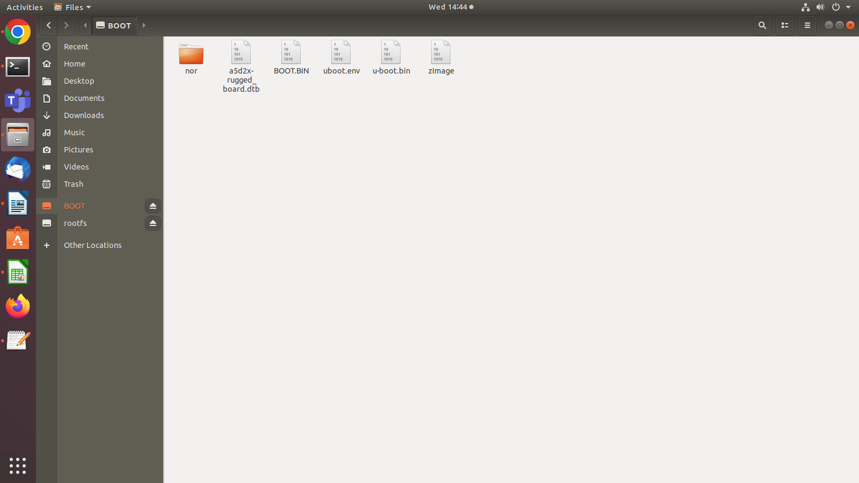

3.SAM-ba_3.2.1 Configuration Tool
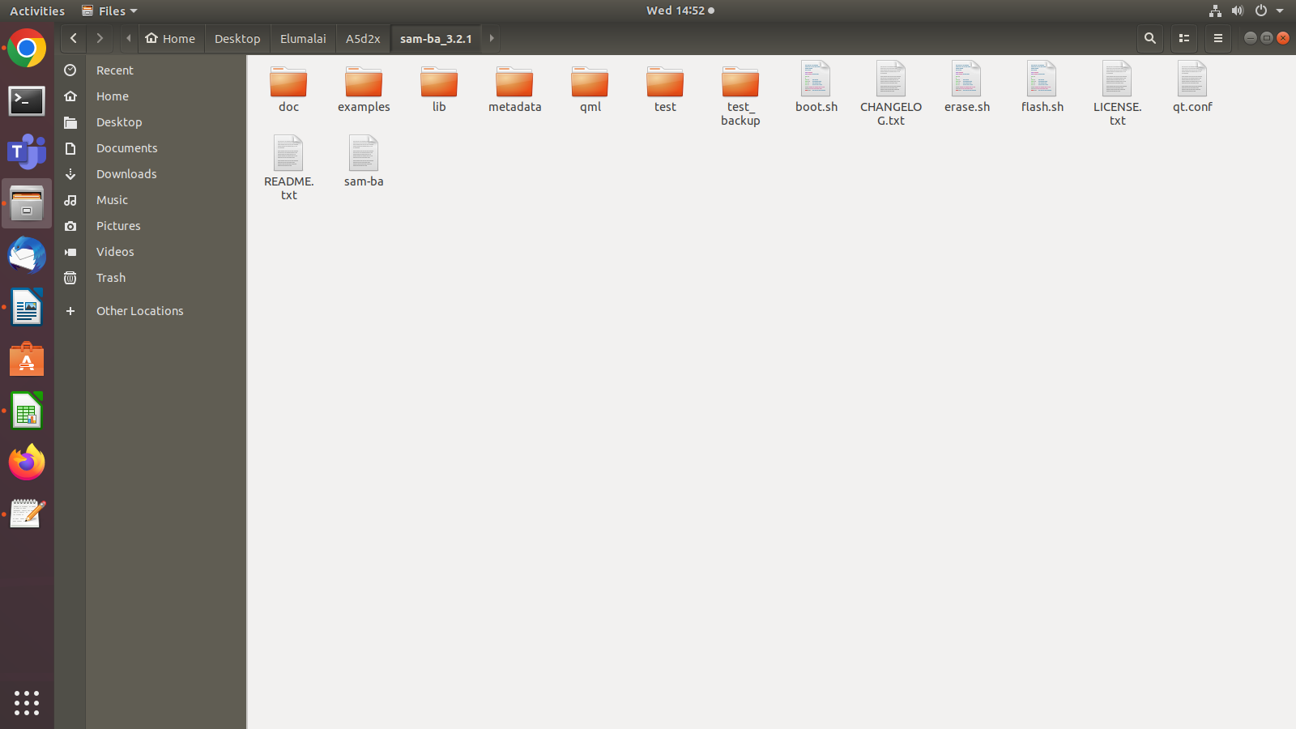

Procedure:

Open one New Terminal (ctl +shift + T )

Give Below Command

board boot register configuration using sam-ba tool:
****************************************************
sudo su
./sam-ba -p usb -b sama5d27-som1-ek1 -a bootconfig -c writecfg:bscr:valid,bureg0

./sam-ba -p usb -b sama5d27-som1-ek1 -a bootconfig -c writecfg:bureg0:ext_mem_boot,sdmmc1,sdmmc0_disabled,nfc_disabled,spi1_disabled,spi0_disabled,qspi1_ioset2,qspi0_disabled

./sam-ba -p usb -b sama5d27-som1-ek1 -a bootconfig -c writecfg:fuse:ext_mem_boot,sdmmc1,sdmmc0_disabled,nfc_disabled,spi1_disabled,spi0_disabled,qspi1_ioset2,qspi0_disabled

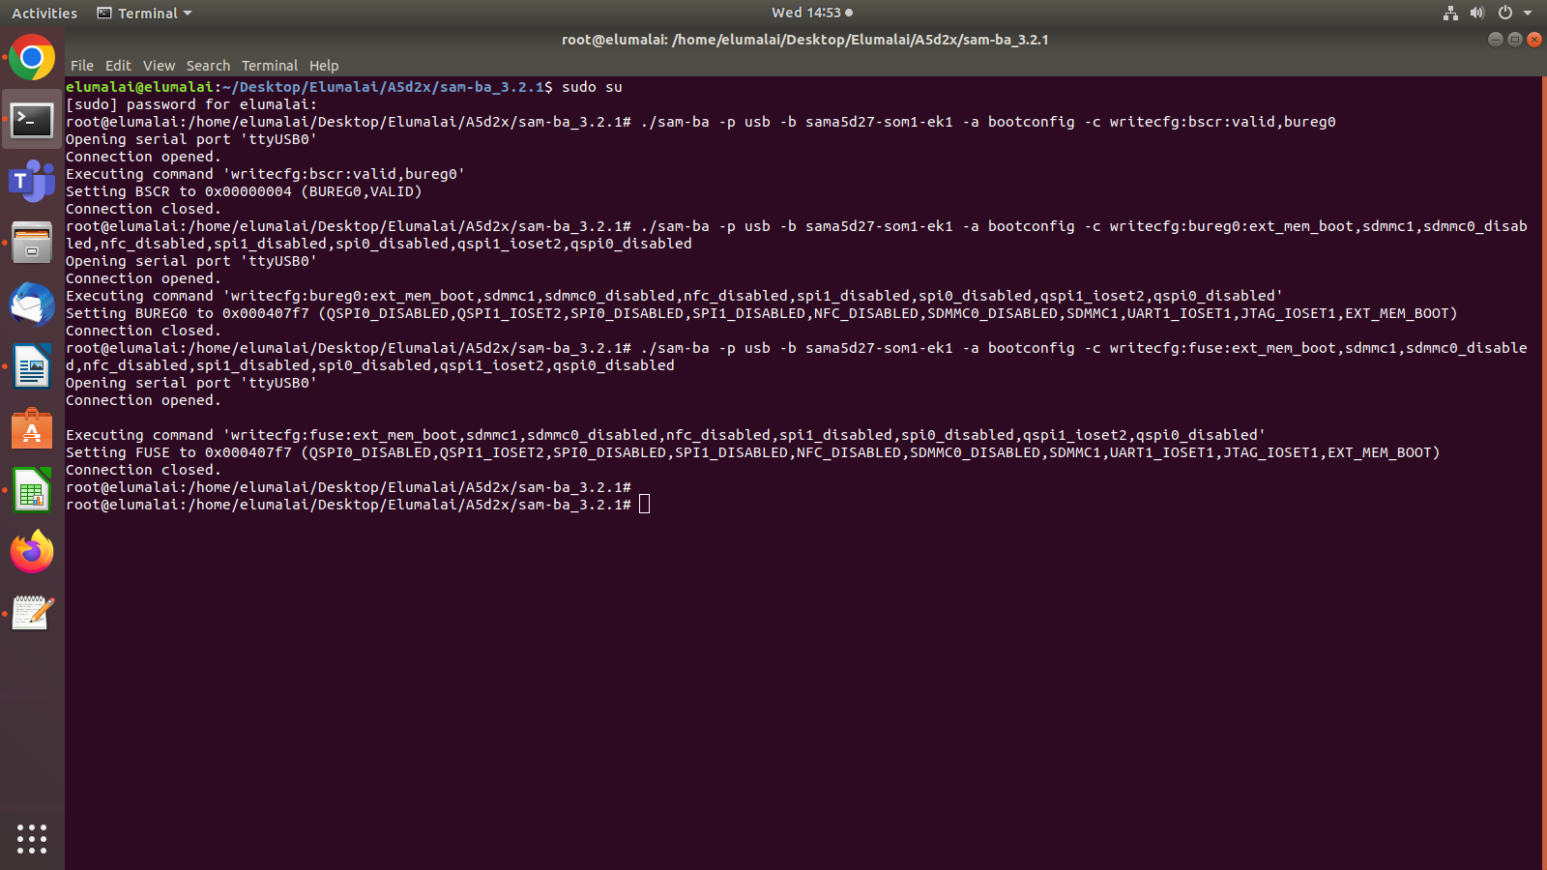
Then open Onather New Terminal and open minicom

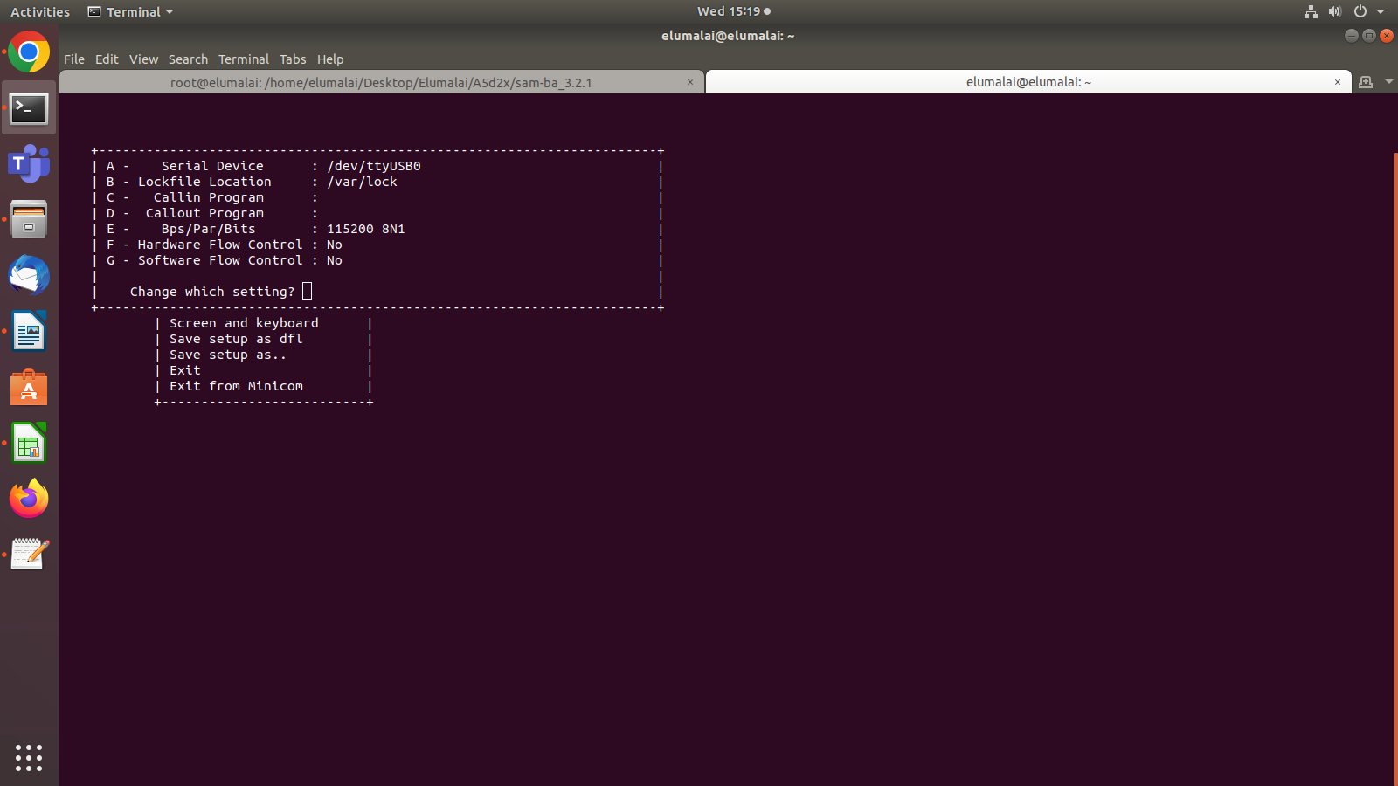

Insert Memory card in Rugged Board . Board by pressing the RESET button and stop at bootloader level by pressing any key on keyboard as below

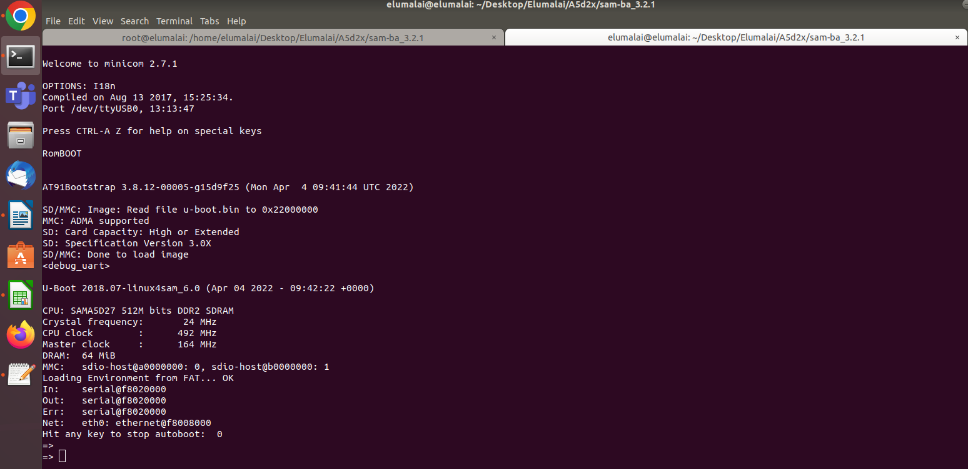
Give Below Command

Board flashing:
***************
sf probe
sf erase 0x0 0x2000000

fatload mmc 1 0x22000000 nor/BOOT.BIN
sf write 0x22000000 0x0 0x10000

fatload mmc 1 0x21FF0000 nor/u-boot.bin
sf write 0x21FF0000 0x20000 0x80000

fatload mmc 1 0x21F70000 nor/a5d2x-rugged_board.dtb
sf write 0x21F70000 0xA0000 0x10000

fatload mmc 1 0x21F60000 nor/zImage
sf write 0x21F60000 0xB0000 0x500000

fatload mmc 1 0x21A60000 nor/rb-nor-core-image-minimal-rugged-board-a5d2x.squashfs
sf write 0x21A60000 0x5B0000 0x01600000

fatload mmc 1 0x20460000 nor/data-image-rootfs.jffs2
sf write 0x20460000 0x01BB0000 0x0450000

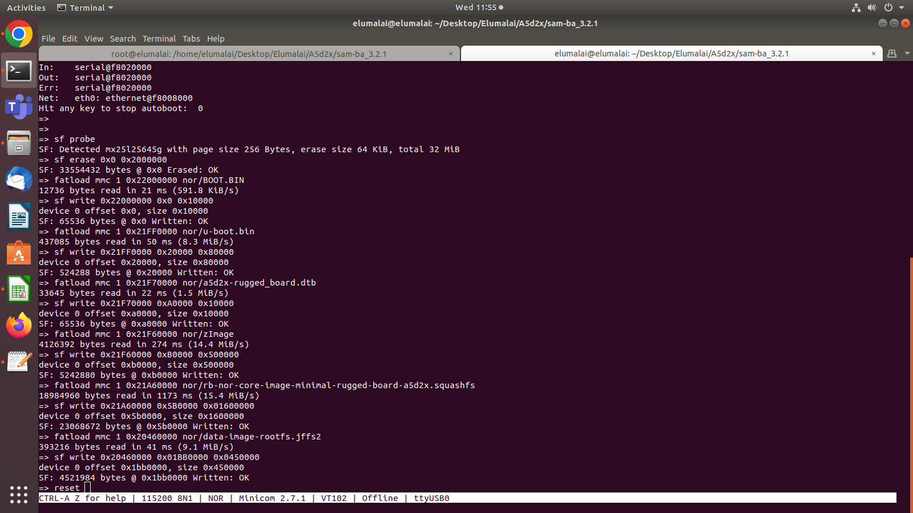

RESET the Rugged Board A5d2x. And remove your SD-Card . Power OFF and power ON Your Board .And press Reset Button Your Board is Readdy

